Laporan Percobaan 2

Tag Device : Nokia 3 Android

Beacon Device : ESP32

Durasi Pengambilan data tiap ruang : 3 menit

Denah Ruangan :

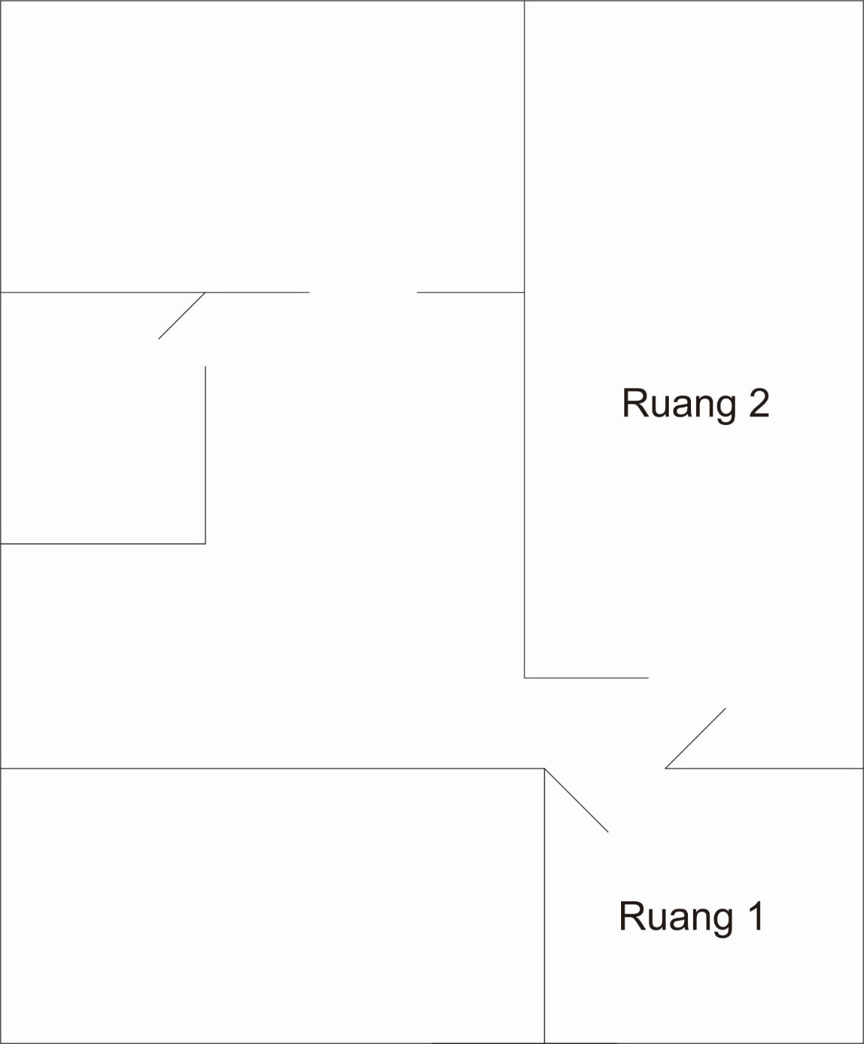

|  |  |  |  |
| --- | --- | --- | --- |
| Ruang 2 | 12:48:21 | 0 | -78 |
| Ruang 2 | 12:48:27 | -90 | -72 |
| Ruang 2 | 12:48:36 | -92 | -71 |
| Ruang 2 | 12:48:39 | 0 | -77 |
| Ruang 2 | 12:48:45 | 0 | -70 |
| Ruang 2 | 12:48:51 | 0 | -70 |
| Ruang 2 | 12:48:57 | -91 | -71 |
| Ruang 2 | 12:49:03 | -93 | -70 |
| Ruang 2 | 12:49:09 | -92 | -77 |
| Ruang 2 | 12:49:15 | -90 | -77 |
| Ruang 2 | 12:49:21 | -91 | -71 |
| Ruang 2 | 12:49:28 | 0 | -71 |
| Ruang 2 | 12:49:34 | 0 | 0 |

Gathering Data Result

|  |  |  |  |
| --- | --- | --- | --- |
| ruang | date_time | beacon1 | beacon2 |
| Ruang 1 | 12:42:39 | -71 | -91 |
| Ruang 1 | 12:42:45 | -78 | 0 |
| Ruang 1 | 12:42:51 | 0 | 0 |
| Ruang 1 | 12:42:57 | -71 | 0 |
| Ruang 1 | 12:43:04 | -71 | 0 |
| Ruang 1 | 12:43:10 | -71 | 0 |
| Ruang 1 | 12:43:16 | -85 | 0 |
| Ruang 1 | 12:43:22 | -73 | 0 |
| Ruang 1 | 12:43:28 | -71 | 0 |
| Ruang 1 | 12:43:34 | -77 | 0 |
| Ruang 1 | 12:43:40 | -78 | 0 |
| Ruang 1 | 12:43:47 | -79 | 0 |
| Ruang 1 | 12:43:52 | -78 | 0 |
| Ruang 1 | 12:43:58 | -78 | 0 |
| Ruang 1 | 12:44:05 | -78 | 0 |
| Ruang 1 | 12:44:11 | -73 | 0 |
| Ruang 1 | 12:44:17 | -78 | 0 |
| Ruang 1 | 12:44:23 | -74 | 0 |
| Ruang 1 | 12:44:29 | -77 | 0 |
| Ruang 1 | 12:44:35 | -78 | 0 |
| Ruang 1 | 12:44:41 | -79 | 0 |
| Ruang 1 | 12:44:47 | -77 | 0 |
| Ruang 1 | 12:44:53 | -78 | 0 |
| Ruang 1 | 12:44:59 | 0 | 0 |
| Ruang 1 | 12:45:05 | -80 | 0 |
| Ruang 1 | 12:45:11 | -74 | 0 |
| Ruang 1 | 12:45:17 | -78 | 0 |
| Ruang 1 | 12:45:23 | -78 | 0 |
| Ruang 1 | 12:45:29 | -77 | 0 |
| Ruang 1 | 12:45:36 | -73 | 0 |
| Ruang 1 | 12:45:42 | -81 | 0 |
| Ruang 1 | 12:45:48 | -78 | 0 |
| Ruang 2 | 12:46:25 | -89 | -47 |
| Ruang 2 | 12:46:31 | 0 | -71 |
| Ruang 2 | 12:46:37 | -94 | -71 |
| Ruang 2 | 12:46:46 | 0 | -77 |
| Ruang 2 | 12:46:49 | 0 | -78 |
| Ruang 2 | 12:46:55 | 0 | -70 |
| Ruang 2 | 12:47:02 | -91 | -70 |
| Ruang 2 | 12:47:11 | -93 | -70 |
| Ruang 2 | 12:47:14 | -89 | -71 |
| Ruang 2 | 12:47:20 | 0 | -71 |
| Ruang 2 | 12:47:26 | 0 | -77 |
| Ruang 2 | 12:47:32 | 0 | -77 |
| Ruang 2 | 12:47:38 | -93 | -77 |
| Ruang 2 | 12:47:44 | 0 | -77 |
| Ruang 2 | 12:47:50 | -92 | -70 |
| Ruang 2 | 12:47:56 | 0 | -78 |
| Ruang 2 | 12:48:03 | -88 | -70 |
| Ruang 2 | 12:48:09 | -90 | -71 |
| Ruang 2 | 12:48:15 | -89 | -72 |